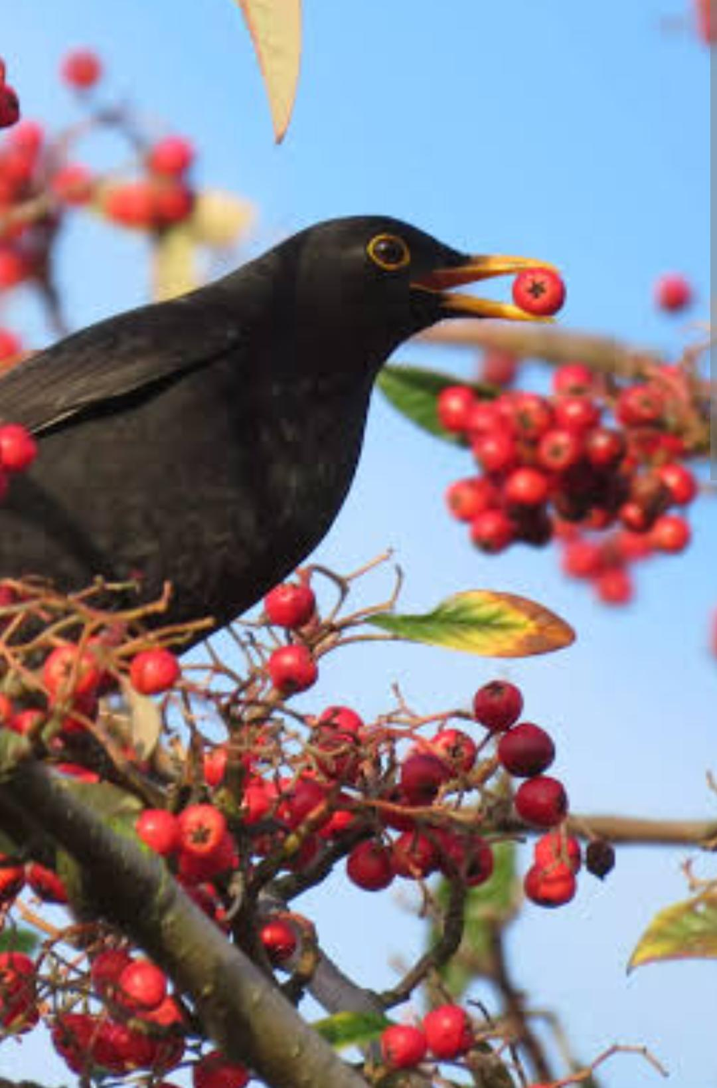
Case Study1: The Amazing Journey of a Seed
Imagine you're a tiny seed, nestled safely inside a juicy fruit or a plump pod. You're dreaming of a day when you'll grow into a tall, strong plant. But first, you need to embark on a journey, a journey that starts with dispersal.
Quesons and Answers
Which among the following is not a seed ?
(a) Chana (b) Rajma (c) Arhar dal (d) Lemon
2.What is NOT necessary for a seed to grow?
(a) Fertilizer (b) Air (c) Water (d) Warmth
3.Which of the following is NOT an agent of dispersal?
(a) Animals (b) Plants (c) Water (d) Wind
4 . The process by which seed move away from its mother plant is called _________________
5 . Statement 1 : Cotton seeds are dispersed by wind .
Reason : Cotton seeds are very light weight .
- Both statement 1 and statement 2 are correct
- Both statement 1 and 2 are wrong
- Both statement 1 and 2 are correct and statement 2 is correct reason for statement 1 .
- None of the above .
Case Study 2
Nutrients are substances in food that the body uses to grow, reproduce, and survive. They provide energy and physical components that allow organisms to perform basic functions like breathing, moving, and responding to the environment. If a person do not take right amount of nutrients along with his/ her diet they may suffer from various deficiency diseases.

Q1 .A diet that comprises of all essential nutrients are called ___________________
Q2 . Name the nutrient responsible for building our muscles and proper growth of body .

Q3. Write any 2 source of energy giving food .

